3. ReactJS-HOL

CalculateScore.js

import React from 'react';

import '../Stylesheets/mystyle.css';

function CalculateScore() {

const name = "John Doe";

const school = "Greenwood High School";

const total = 450;

const goal = 500;

const average = (total / goal) * 100;

return (

<div className="score-container">

<h2>Student Score Report</h2>

<p><strong>Name:</strong> {name}</p>

<p><strong>School:</strong> {school}</p>

<p><strong>Total Marks:</strong> {total}</p>

<p><strong>Goal:</strong> {goal}</p>

<p><strong>Average Score:</strong> {average.toFixed(2)}%</p>

</div>

);

}

export default CalculateScore;

mystyles.css

.score-container {

margin: 40px auto;

padding: 30px;

border: 2px solid #444;

width: 400px;

background-color: #f5f5f5;

text-align: left;

font-family: Arial, sans-serif;

}

.score-container h2 {

color: #2c3e50;

text-align: center;

}

.score-container p {

font-size: 16px;

margin: 8px 0;

}

App.js

import React from 'react';

import CalculateScore from './Components/CalculateScore';

function App() {

return (

<div>

<CalculateScore />

</div>

);

}

export default App;

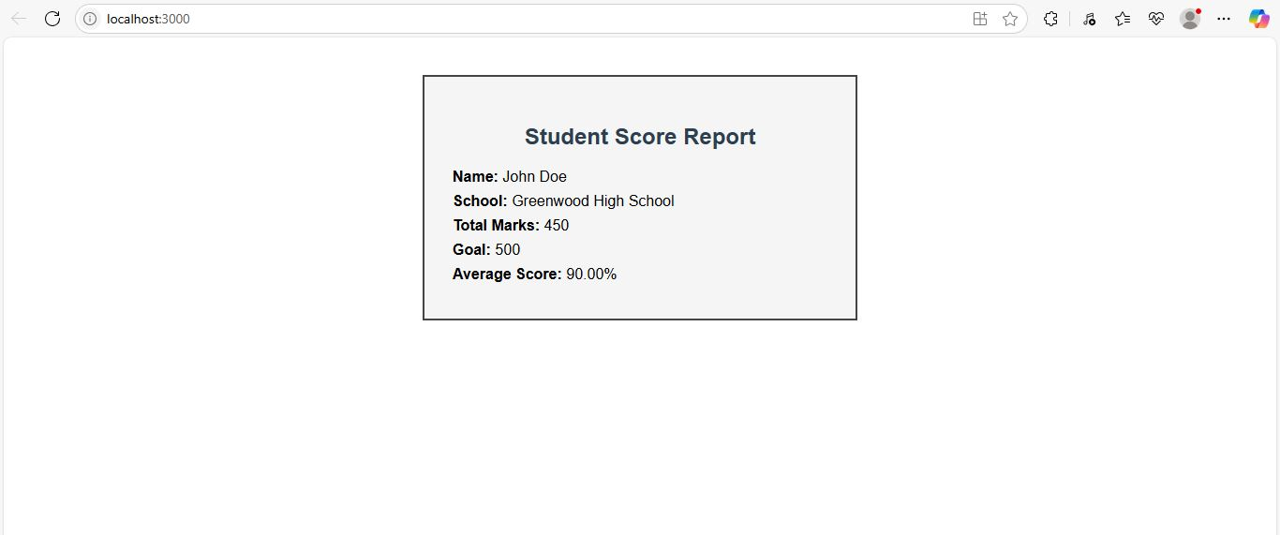

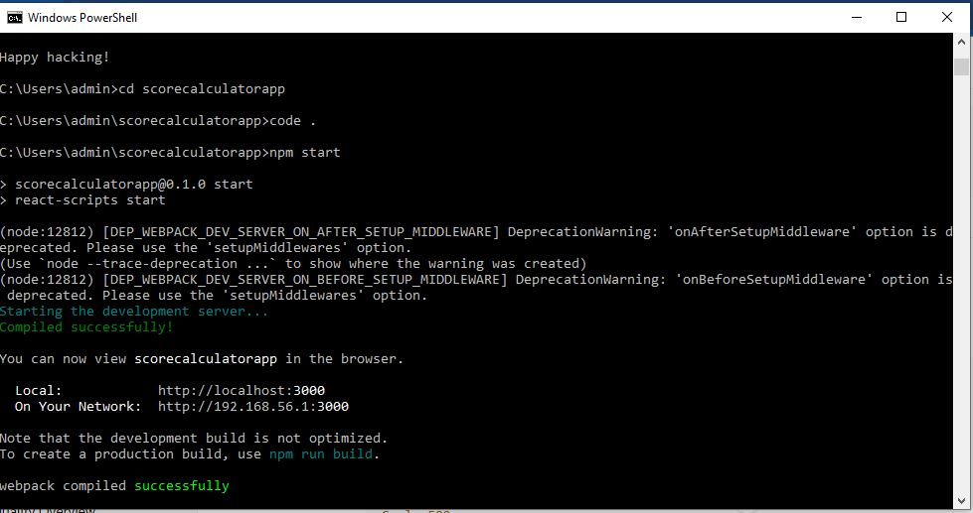

1. Explain React components
React components are independent, reusable pieces of UI in a React application. They return JSX to describe what should appear on the screen.

2. Identify the differences between components and JavaScript functions
Feature | React Components | JavaScript Functions
Purpose | Create UI elements | Perform logic or calculations
Return | JSX (HTML-like) | Any data type
Usage | Can accept props and manage state | No React-specific behavior
Integration | Used inside React rendering | Used for utility or logic

3. Identify the types of components
- Function components
- Class components

4. Explain class component
A class component is a React component defined using ES6 class syntax. It supports state and lifecycle methods.

5. Explain function component
A function component is a JavaScript function that returns JSX. Since React 16.8, it can use Hooks to manage state and side effects.

6. Define component constructor
In class components, the constructor initializes state and binds methods. It's not used in function components.

7. Define render() function
The render() method is used in class components to return the UI. It's not required in function components, which directly return JSX.

